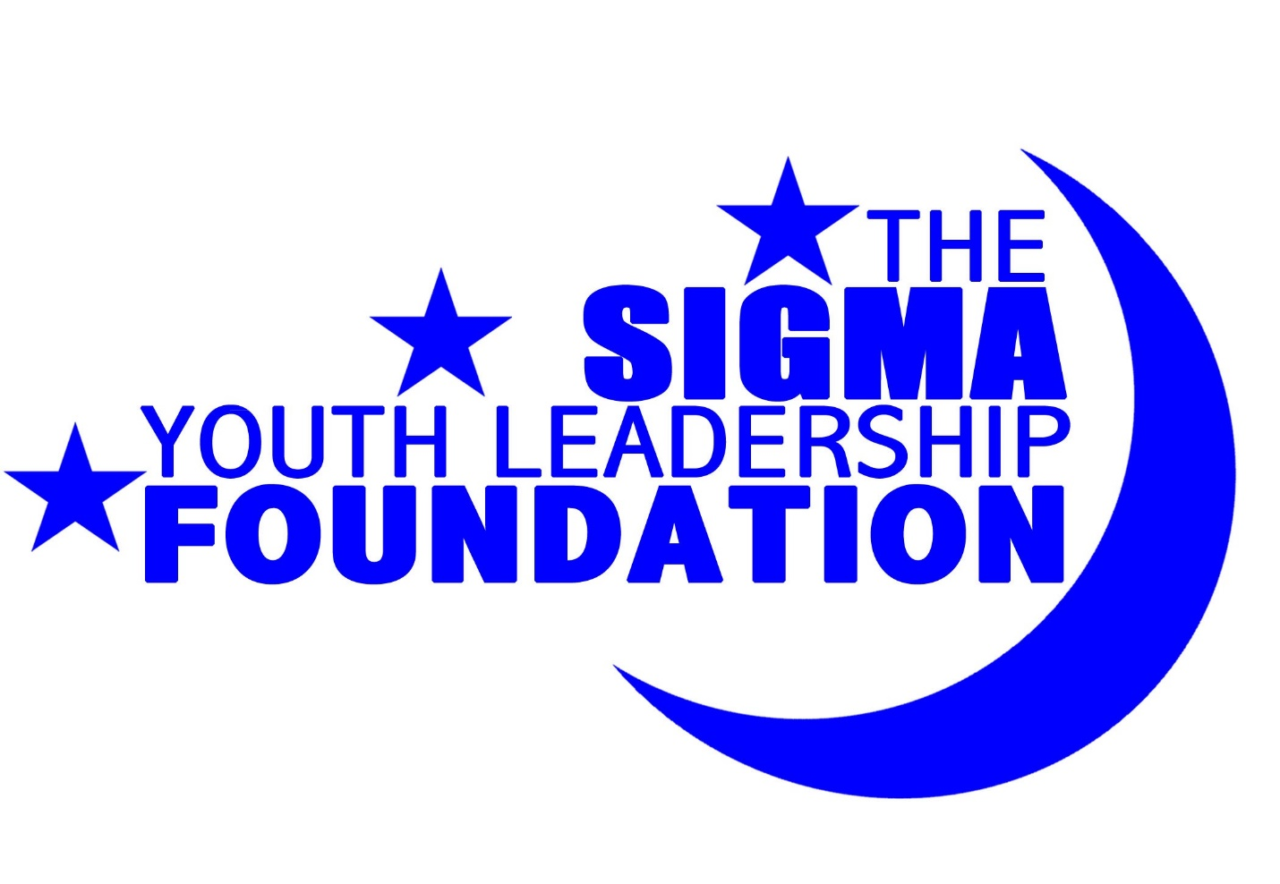
“Passing the Torch from Generation to Generation”

2019 James Weldon Johnson Scholarship Application

Dear Scholarship Applicant:

Thank you for your interest in becoming a part of a long-standing tradition with the Sigma Youth Leadership Foundation, Incorporated. We are currently seeking individuals that exemplify the qualities of scholarship that will be honored at our annual SYLF Scholarship Reception, “Passing the Torch from Generation to Generation.”

We are now accepting applications for the 2019 James Weldon Johnson High School Scholarship. In order to apply for this application, you must meet the following criteria:
- Must be a male student presently enrolled as a high school senior at a high school located in the state of Georgia.
- Must have a minimum cumulative 3.0 GPA at the time of the application deadline.
- Should be a responsible, supportive, self-disciplined, positive, and energetic individual who is interested in the welfare of education and in the community.
- Must attend the SYLF Scholarship Reception to receive the award on Saturday, June 1, 2019. Selected Scholarship winner(s) will be notified of the venue and any change in date by April 26th, 2019.

Enclosed you will find the 2019 James Weldon Johnson scholarship application with forms attached. The scholarship application must be emailed by Friday, February 15, 2019 no later than 11:59pm. Please make sure that the following forms/documents are turned in:
- COMPLETED 2019 James Weldon Johnson Scholarship Application
- Current Resume
- Scholarship Essay (4 pages maximum)
- OFFICIAL copy of high school transcript
- Two letters of recommendation from a faculty/staff member (teacher, principal, and/or guidance counselor), employer, or coach/organizational sponsor who can assess your skills.

Once we receive your application, an email confirming that we have received it will be provided. Incomplete or late applications will not be accepted! NO EXCEPTIONS! After all applications have been received, applicants will be assessed using a points system using the following information:
- Application with resume
- Grade Point Average
- Recommendation Letters
- Scholarship Essay
- Overall Presentation

If you have any questions about the scholarship application, please contact me at sylf@sigmayouthleadership.org. Thank you for your time and good luck with the process!

Sincerely,

2019 SYLF Scholarship Committee
Sigma Youth Leadership Foundation, Inc
P.O. Box 831792, Stone Mountain Ga, 30083.

James Weldon Johnson (1871-1838)

James Weldon Johnson was born on June 17, 1871 in Jacksonville, Florida. He is best known as being a poet, composer, diplomat, and anthologist of black culture.

James was trained in music and other subjects by his mother, a schoolteacher. Johnson graduated from Atlanta University with an A.B. in 1894. He later obtained a M.A. in 1904 while studying at Columbia. For several years, he was principal of the black high school in Jacksonville. He read law at the same time, and was admitted to the Florida bar in 1897, and began practicing there. During this period, he and his brother, John Rosamond Johnson (1873-1954), a composer, began writing songs. In 1901, the two went to New York, where they wrote some 200 songs for the Broadway musical stage.

In 1906, President Theodore Roosevelt appointed him U.S. consul to Puerto Cabello, Venezuela. And in 1909, he became consul in Corinto, Nicaragua, where he served until 1914. He later taught at Fisk University. Meanwhile, he began writing a novel, Autobiography of an Ex-Colored Man (published anonymously in 1912), which attracted little attention until it was reissued under his own name in 1927. From 1916, Johnson was a leader in the National Association for the Advancement of Colored People (NAACP). It was during this time that James W. Johnson became a distinguished member of Phi Beta Sigma Fraternity, Inc., joining fellow members of the time like George Washington Carver.

One of his famous poems was “Lift Every Voice and Sing”. His brother later added music to the poem. It is considered to be the unofficial Negro National Anthem. It was a bold piece of work that spoke of the struggle of African-Americans in America and his optimistic hope for a better future.

Some of his other works include Fifty Years and Other Poems (1917) which was followed by his pioneering anthology Book of American Negro Poetry (1922) and books of American Negro Spirituals (1925-1926), collaborations with his brother. His best-known work, God’s Trombones (1927), a group of black dialect sermons in verse, includes “The Creation” and “Go Down Death”. Johnson’s introductions to his anthologies contain some of the most perceptive assessments ever made of black contributions to American culture. Along This Way (1933) is an autobiography.
Scholarship Rules and Guidelines

In order to be eligible to receive the 2019 James Weldon Johnson Scholarship, the following rules apply:

- Must be an African-American male presently enrolled as a high school senior at a high school located in the state of Georgia.
- Must have a minimum cumulative 3.0 GPA at the time of the application deadline.
- Should be a responsible, supportive, self-disciplined, positive, and energetic individual who is interested in the welfare of education and in the community.
- A total of one scholarship will be awarded. The number of awards is at the sole discretion of the SYLF scholarship committee.
- The scholarship will be worth $1,000 and it is non-renewable. The award will be provided to the student in one payment of $1,000.
- The scholarship is intended to be used at an accredited college or university in the state of Georgia and will be made payable to the selected school.
- The SYLF scholarship committee will judge the submitted scholarship applications. Finalists will be selected based on the application and attached documents. The scholarship recipient will be chosen and notified by Saturday, March 30, 2019.
- The SYLF scholarship committee reserves the right to conduct an interview of the finalists.
- The scholarship recipients will be determined by the Sigma Youth Leadership Foundation. It is solely at the discretion of the SYLF scholarship committee to make the determination of which applicants followed the guidelines as set forth in the application.
- The winner must attend the scholarship reception to receive the award on Saturday, June 1, 2019.

Please be sure to complete the scholarship application form and include ALL attachments listed below. Failure to adhere to the instructions will result in disqualification of your application.

- COMPLETED 2019 James Weldon Johnson Scholarship Application
- Current resume
- An official copy of your high school transcript showing your cumulative GPA
  - mailed to Sigma Youth Leadership Foundation, P.O. Box 831792, Stone Mountain Ga, 30083.
- Two letters of recommendation:
  - Each recommendation must be submitted directly via email from the following:
    - Faculty/staff member (teacher, principal, and/or guidance counselor); employer, or coach/organizational sponsor who can assess your skills.
    - NOTE: All recommenders must submit their letters directly to sylf@sigmayouthleadership.org by the application deadline. Please inform recommenders to utilize the email Subject format: “J.W.J. Scholarship Recommendation – Your Name”
- A 2-4 page scholarship essay (information will be included in application)

Your completed application package should be saved as a zipped archive of the required application package files with the file name “James Weldon Johnson Scholarship – Your Name.zip” and emailed to sylf@sigmayouthleadership.org by Friday, February 15, 2019 no later than 11:59pm. Completed written applications and all associated attachments (including official sealed transcript and recommendation letters) can also be mailed to Sigma Youth Leadership Foundation, P.O. Box 831792, Stone Mountain Ga, 30083. Must be postmarked by February 15, 2019.

Please email your completed application package with the email Subject “James Weldon Johnson Scholarship – Your Name” since we will be receiving a number of applications during this application process.

2019 James Weldon Johnson
Scholarship Application

Please print clearly or type and attach a current resume.

Part I: Personal Information

Name: ________________________________________________________________________________________________

Address: _____________________________________________________________________________________________

City: __________________________________ State: _______________________________ Zip Code: _____________

Home Phone: ______________________________________ Cell Phone: ___________________________________

Email Address: ______________________________________________________________________________________

Date of Birth: _____________________________________________________ Age: ____________________________

Part II: High School Information

Name of School: _____________________________________________________________________________________

Address: _____________________________________________________________________________________________

City: __________________________________ State: _______________________________ Zip Code: ____________

Cumulative GPA: ________ / ________ Expected Date of Graduation: ___________________________
(i.e. 3.5/4.0 scale)

OPTIONAL – SAT Combined Score: _________________ ACT Composite Score: ________________

Part III: Applicant’s Colleges/Universities Applying To

 | Name of Institution | Location (City, State)
1
2
3
4
5
6
7
8
*If you have been accepted to any of these schools, please put (ACCEPTED) next to the school’s name.
Part IV: Short Answer
Please answer the following questions concisely and attach additional sheets if needed.

- What other scholarships, grants, or financial aid awards have you received or do you expect to receive for the 2019 school year?

Award Name | Date | Amount

- What academic awards, recognitions, or honors have you received during your high school career?

Award Name | Description | Date

- What community service activities or organizations have you been involved with in the last year?

Activity/Organization | Role | Date Participated

- List all your involvement in student organizations. Please include if you have held any leadership positions and years involved.

Activity/Organization | Position | Dates Participated

- List all of your current and previous work experience. Please include the type of work you did, how many hours you worked per week, and length of employment.

Employer | Position | Dates Participated | Hours Per Week

- Why should you receive this year’s James Weldon Johnson Scholarship? What type of impact would this scholarship have on your education?

Part V: Essay

Topic: Considering what you have witnessed and experienced in the media, in your community and in school, what do you think is the most pressing societal issue we face today and why? How will this issue affect your generation and future generations to come if it is not handled? In what ways do you desire to change the landscape of your community with the opportunities you will gain from a college education?

Essay Criteria:
- Your essay should be between two to four pages, double-spaced and typed.
- Size 12 font (only Times New Roman or Arial font are accepted)
- Your essay will be judged based on the following:
  - The degree to which the writer establishes a controlling idea and elaborates the main points with examples, illustrations, facts or details that are appropriate to the audience.
  - The degree to which the writer’s ideas are arranged in a clear order and the overall structure of the response is consistent to the audience.
  - The degree to which the writer controls language to engage the reader.
  - The degree to which the writer demonstrates control of sentence formation, usage, and mechanics.
- The essay will account for a major portion of the scoring criteria for the awarding of the scholarship.

Part VI: Recommendations and Transcripts

Recommendations
Each applicant must have TWO letters of recommendation for their application package. Each recommendation letter must be submitted directly from your recommender to sylf@sigmayouthleadership.org by the application deadline or the application will be considered incomplete. Please inform recommenders to utilize the email Subject format: “J.W.J. Scholarship Recommendation – Your Name”. Faculty/staff members (teachers, principals, and/or guidance counselors); employers; and coaches/organizational sponsors are all acceptable recommenders who can assess your skills.

Transcripts
Applicants obtain an official sealed copy of their high school transcript. The transcript should show the applicant’s GPA and, if possible, the applicant’s percentile rank. Applications are considered incomplete until transcripts and/or academic verifications are received by the SYLF scholarship committee. Please mail to Sigma Youth Leadership Foundation, P.O. Box 831792, Stone Mountain Ga, 30083.

Part VII: Applicant Verification

By signing this application, I affirm that all information contained within this application and accompanying attachments are complete, accurate and all information is truthful. Also by signing this application, I authorize the Sigma Youth Leadership Foundation Scholarship Committee to check my academic transcript to verify my current cumulative GPA.

Applicant
Printed Name: _________________________________________________________________________________________________

Signature: ______________________________________________________________________________________________________

Date: ____________________________________________________________________________________________________________

Parent/Guardian
Printed Name: _________________________________________________________________________________________________

Signature: ______________________________________________________________________________________________________

Date: ____________________________________________________________________________________________________________

NOTE: If selected, parent or guardian must accompany applicant to the scholarship banquet.

Scholarship Application Package Checklist

The following checklist is provided for the applicant’s benefit. To be eligible for this scholarship, the applicant must make sure all of the following are done and the completed application package must be submitted to sylf@sigmayouthleadership.org by Friday, February 15, 2019 no later than 11:59pm please save all files of the application package as a zipped archive with the file name “James Weldon Johnson Scholarship – Your Name.zip”):

- COMPLETED 2019 James Weldon Johnson Scholarship Application
- Applicant’s Current Resume
- OFFICIAL Copy of High School Transcript (mailed to Sigma Youth Leadership Foundation, P.O. Box 831792, Stone Mountain Ga, 30083.)
- Scholarship Essay (4 pages maximum)
- Two Letters of Recommendation sent directly to sylf@sigmayouthleadership.org.

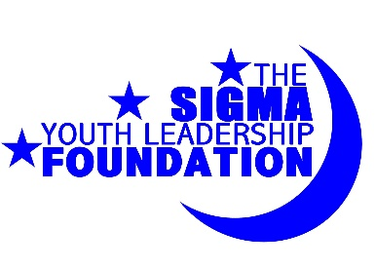
If you have any questions or concerns, please contact SYLF Scholarship Committee at sylf@sigmayouthleadership.org. Good luck with the application process!

